**ImageJ Analysis Macros**

**Macro: Erosion (Territories)**

**Overview**

The task is to calculate the mean FITC and/or TxRd signal within 5 concentric shells with equal area within the nucleus. The macro creates a results table containing various intensity based statistical parameters for the channels specified.

**Supported image types**

Either 2D 24bit colour or 16bit stack files from Micro-Manager

**Instructions**

The macro begins with a message to remind the user that the images should be calibrated in µm before running. The macro then prompts the user to identify a folder containing the images to be analysed. The folder should only contain images. A second prompt appears to select the folder for storing the results which can be the same or a different folder.

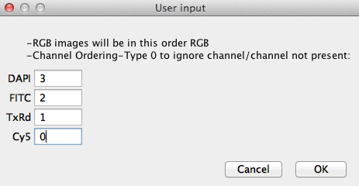The images to be analysed could contain up to 4 channels in any order therefore a dialog appears which allows the user to input which frame of the stack file contains which channel. In this example DAPI is frame 3, FITC 2 etc. Entering 0 for any particular channel tells the macro that either that channel is not present in the image or it is not to be analysed.

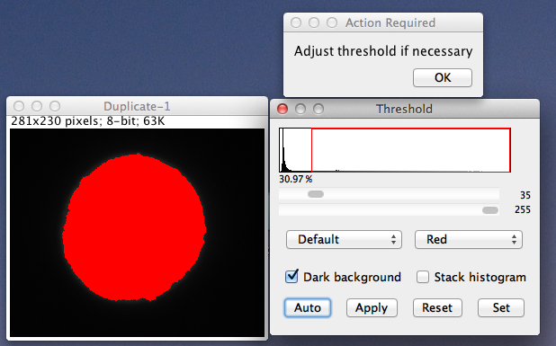

From here the analysis begins starting with segmentation of the nucleus. Auto-threshold is used but the user can interact at this stage to change the threshold value if it is not appropriate.

A Gaussian blur step can be toggled on/off in the code to enable easier thresholding of the nucleus.

When the analysis of the current image is complete a dialog appears with the following options:

-Append result and continue

-Skip this image

-Exit

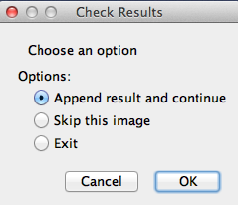

The purpose of this is to allow the user to assess the analysis results and then either append them to the existing results table, save the concentric ring image and then move on to the next image in the folder. Skip the current image if the results are unsatisfactory and move on to the next or simply exit and stop the macro.

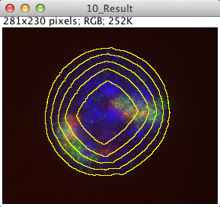The results consist of the merged image complete with the concentric rings to indicate how the image has been sub-divided and the results table containing the measurements. Each row contains the measurements extracted from one of the concentric rings ascending from the outermost ring (row 1) to the innermost ring (row 5). The ROI measured is the area between two consecutive yellow rings.

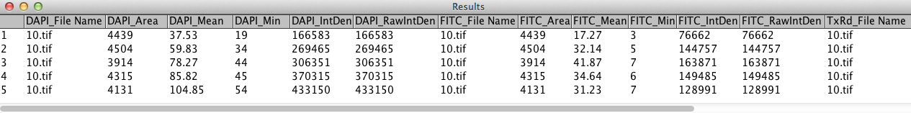

**Analysis Background Information**

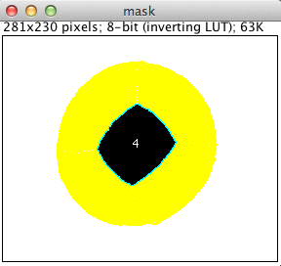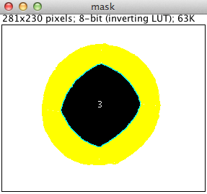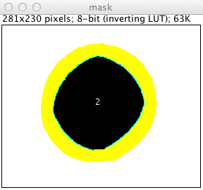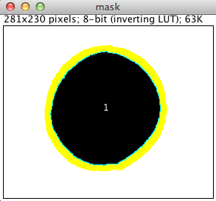Creation of the concentric rings is based on the erosion morphological operator working on a binary mask of the segmented nucleus, the area of which is known. Erosion removes pixels from the edge of an object and in this manner the nuclear mask is eroded away through consecutive loops until the area is 4/5 of the original area. At this point a ring ROI is added to the image. This process continues until the area is eroded to 3/5 of the original at which point another ring ROI is added to the image and so on. Below images show the erosion process after several iterations on the nucleus mask.

A background subtraction operation (rolling ball) is performed on the analysed image channels to remove the contribution from low intensity background signal that would otherwise skew the statistics.

**Macro: Erosion (FISH)**

**Overview**

The aim is to identify and count the number of FISH probes found within 5 concentric rings of equal area starting at the outer boundary of the nucleus. This is used as an estimate of gene position within the nucleus and results between different images are always comparable as each ring always represents 1/5 of the total nucleus area. A row of the results table shows the number of probes found within a particular nucleus. Each column represents the number of probes found in the area between two consecutive rings.

**Supported image types**

Either 2D 24bit colour or 16bit stack files from Micro-Manager

**Instructions**

The macro begins with a message to remind the user that the images should be calibrated in µm before running. The macro then prompts the user to identify a folder containing the images to be analysed. The folder should only contain images. A second prompt appears to select the folder for storing the results which can be the same or a different folder.

The images to be analysed could contain up to 4 channels in any order therefore a dialog appears which allows the user to input which frame of the stack file contains which channel. In this example DAPI is frame 3, FITC 2 etc. Entering 0 for any particular channel tells the macro that either that channel is not present in the image or it is not to be analysed.



From here the analysis begins starting with segmentation of the nucleus. Auto-threshold is used but the user can interact at this stage to change the threshold value if it is not appropriate.

A Gaussian blur step can be toggled on/off in the code to enable easier thresholding of the nucleus.

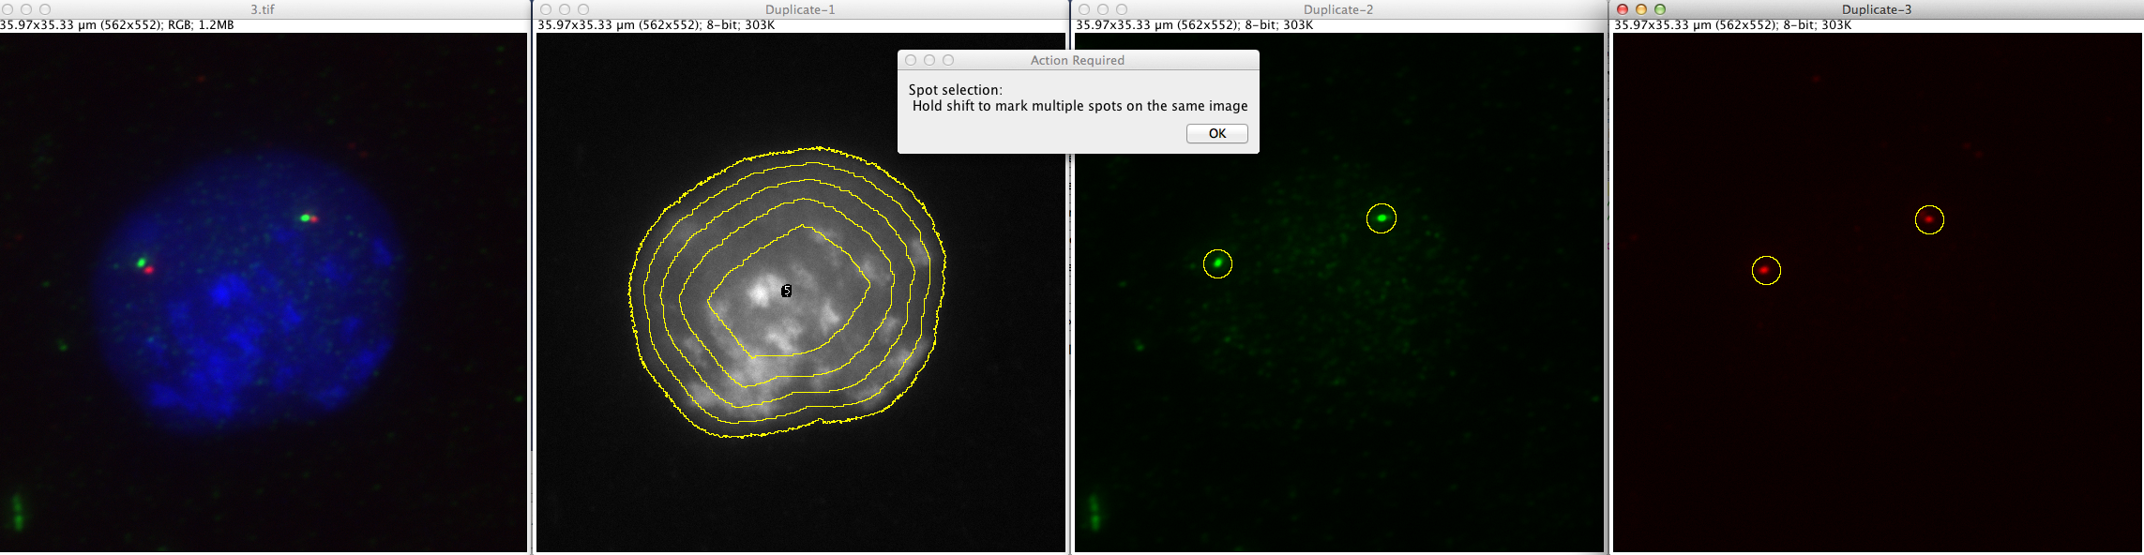The next interactive step asks the user to click on the probes in each image channel which should be counted. A pre-defined circular ROI is used to mark the probes. To select only one probe per image channel, left click on the probe and then press the “t” key on the keyboard. If you would like to mark more than one probe per channel image, hold the “shift” key on the keyboard while clicking on the probes. Do not mark probes on a channel that you previously indicated you didn’t want to me measured (previous textbox dialog). If more than one probe is found in the same channel within the same ROI they will be counted. Select Ok in the dialog to begin the counting process.

When the analysis of the current image is complete a dialog appears with the following options:

-Append result and continue

-Skip this image

-Exit

The purpose of this is to allow the user to assess the analysis results and then either append them to the existing results table, save the concentric ring image and then move on to the next image in the folder. Skip the current image if the results are unsatisfactory and move on to the next or simply exit and stop the macro.

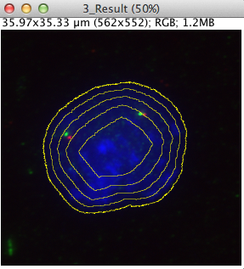

The results consist of the merged image complete with the concentric rings to indicate how the image has been sub-divided and the results table containing the measurements. The outer rings are measured first moving inwards towards the centre of the nucleus. Each column lists how many probes have been found between each pair of rings.

**Analysis Background Information**

Creation of the concentric rings is based on the erosion morphological operator working on a binary mask of the segmented nucleus, the area of which is known. Erosion removes pixels from the edge of an object and in this manner the nuclear mask is eroded away through consecutive loops until the area is 4/5 of the original area. At this point a ring ROI is added to the image. This process continues until the area is eroded to 3/5 of the original at which point another ring ROI is added to the image and so on. Below images show the erosion process after several iterations on the nucleus mask.

The probes are identified using the Find Maxima function with the noise parameter set differently for 24bit vs 16bit images. A mask of each channel is produced where each probe is represented as a single pixel. This ensures that any particular probe can only be counted between one pair of consecutive rings, even if it sits very close to a ring boundary.

**Macro: Spot Distance 2D**

**Overview**

A macro to measure the distance in µm between selected FISH probes in multiple channels. Flexibility has been added to allow distance measurements between either 2 or 3 probe channels.

**Supported image types**

Either 2D 24bit colour or 16bit stack files from Micro-Manager

**Instructions**

The macro begins with a message to remind the user that the images should be calibrated in µm before running. The macro then prompts the user to identify a folder containing the images to be analysed. The folder should only contain images. A second prompt appears to select the folder for storing the results which can be the same or a different folder.

The images to be analysed could contain up to 4 channels in any order therefore a dialog appears which allows the user to input which frame of the stack file contains which channel. In this example DAPI is frame 3, FITC 2 etc. Entering 0 for any particular channel tells the macro that either that channel is not present in the image or it is not to be analysed.



From here the analysis begins starting with segmentation of the nucleus. Auto-threshold is used but the user can interact at this stage to change the threshold value if it is not appropriate.

A Gaussian blur step can be toggled on/off in the code to enable easier thresholding of the nucleus.

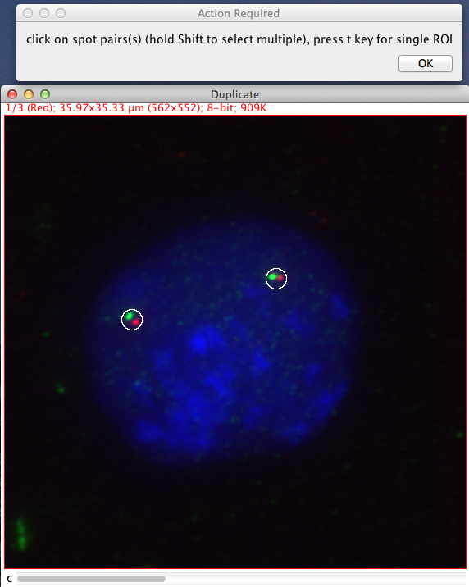

The next interactive step asks the user to click on the probe pairs/triplets that should be measured. A pre-defined circular ROI is used to mark the probes. To select only one probe pair/triplet, left click on the probe and then press the “t” key on the keyboard. If you would like to mark more than one probe pair, hold the “shift” key on the keyboard while clicking on the probes. Do not mark probes on a channel that you previously indicated you didn’t want to me measured (previous textbox dialog). If more than one probe is found in the same channel within the same ROI only the distance from the larger probe is measured. Select Ok in the dialog to begin the distance calculations.

When the analysis of the current image is complete a dialog appears with the following options:

-Append result and continue

-Skip this image

-Exit

The purpose of this is to allow the user to assess the analysis results and then either append them to the existing results table, save the merged image complete with inter-probe lines and then move on to the next image in the folder. Skip the current image if the results are unsatisfactory and move on to the next or simply exit and stop the macro.

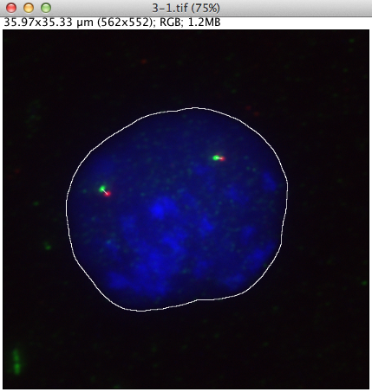

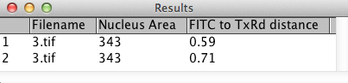The results consist of a merged image showing lines drawn between the probes whose inter-probe distances have been calculated and a table showing the distance measurements. Each probe pair/triplet occupies a different row in the table.

**Analysis Background Information**

Identification of the probes is based on auto-threshold using the histogram from the ROI only. The center of masses (weighted centroids) of the probes are stored. If an ROI contains more than one probe of the same colour, it is assumed the biggest probe is to be measured and the smaller is ignored. The distances can be found either using trigonometry or in this case, lines are drawn between the probe centres and the length of the lines measured.

**Macro: Spot Distance to nucleus boundary 2D**

**Overview**

This macro identifies FISH probes and then measures the distance from each probe centre to the nearest edge of the nucleus. It is possible to analyse 3 and 4 channel images.

**Supported image types**

Either 2D 24bit colour or 16bit stack files from Micro-Manager

**Instructions**

The macro begins with a message to remind the user that the images should be calibrated in µm before running. The macro then prompts the user to identify a folder containing the images to be analysed. The folder should only contain images. A second prompt appears to select the folder for storing the results which can be the same or a different folder.

The images to be analysed could contain up to 4 channels in any order therefore a dialog appears which allows the user to input which frame of the stack file contains which channel. In this example DAPI is frame 3, FITC 2 etc. Entering 0 for any particular channel tells the macro that either that channel is not present in the image or it is not to be analysed.



From here the analysis begins starting with segmentation of the nucleus. Auto-threshold is used but the user can interact at this stage to change the threshold value if it is not appropriate.

A Gaussian blur step can be toggled on/off in the code to enable easier thresholding of the nucleus.

The next interactive step asks the user to click on the probe pairs/triplets that should be measured. A pre-defined circular ROI is used to mark the probes. To select only one probe pair/triplet, left click on the probe and then press the “t” key on the keyboard. If you would like to mark more than one probe pair, hold the “shift” key on the keyboard while clicking on the probes. Do not mark probes on a channel that you previously indicated you didn’t want to me measured (previous textbox dialog). If more than one probe is found in the same channel within the same ROI only the distance from the larger probe is measured. Select Ok in the dialog to begin the distance calculations.

When the analysis of the current image is complete a dialog appears with the following options:

-Append result and continue

-Skip this image

-Exit

The purpose of this is to allow the user to assess the analysis results and then either append them to the existing results table, save the merged image complete with inter-probe lines and then move on to the next image in the folder. Skip the current image if the results are unsatisfactory and move on to the next or simply exit and stop the macro.

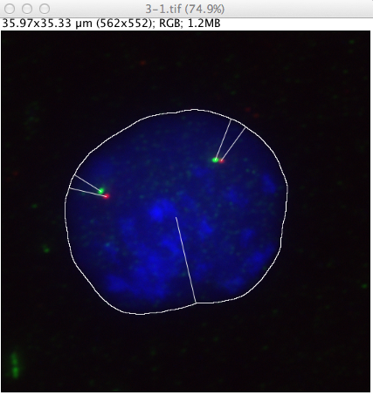

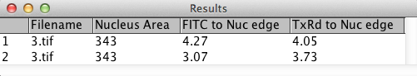The results consist of a merged image showing lines drawn between the probes and the nearest nuclear edge and a table showing the distance measurements. Each probe pair/triplet occupies a different row in the table.

**Analysis Background Information**

Identification of the probes is based on auto-threshold using the histogram from the ROI only. The center of masses (weighted centroids) of the probes are stored. If an ROI contains more than one probe of the same colour, it is assumed the biggest probe is to be measured and the smaller is ignored. The shortest distance to the nucleus periphery for each probe is calculated by measuring the distance from each probe centre to each pixel on the nucleus perimeter then choosing the shortest distance. The distances are calculated by measuring the length of each line.

**Macro: DAPI Bands**

**Overview**

If DAPI staining is too uniform to permit unequivocal identification of chromosomes, linear filters can be employed to improve the mid range contrast of chromosome bands. This macro uses a series of crispening convolutions to improve DAPI banding.

**Supported image types**

A single open 8 or 16bit DAPI image

**Instructions**

To run the macro on a ROI only, crop the image before running using Image>Crop

There is an option to display the results as tiles side by side or as a cascade (stacked one behind the other). Each images title contains the convolution kernel used to produce that image.

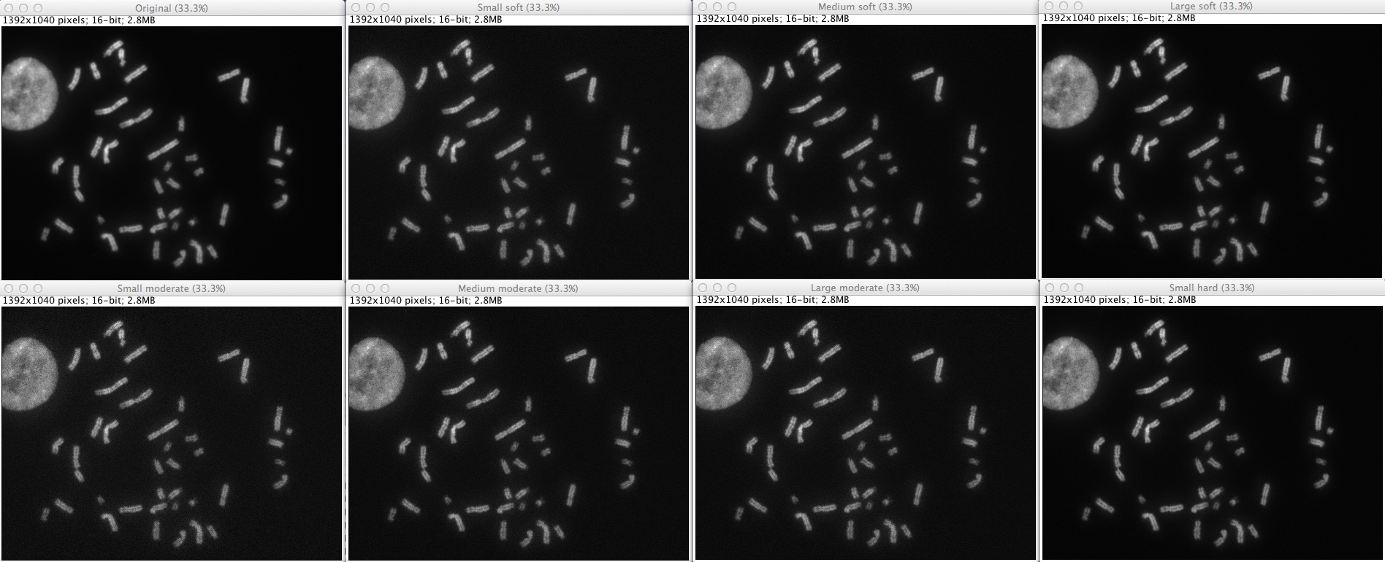

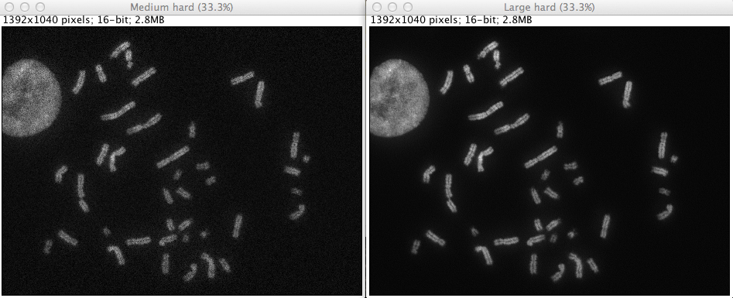

**Analysis Background Information**

Below is the list of crispening convolution kernels used on the original image

**Small soft**

0 0 0 0 0 0 -1 -1 -1 0 0 -1 12 -1 0 0 -1 -1 -1 0 0 0 0 0 0

**Medium soft**

0 0 -1 0 0 0 -1 1 -1 0 -1 1 8 1 -1 0 -1 1 -1 0 0 0 -1 0 0

**Large soft**

-1 -1 -1 -1 -1-1 2 2 2 -1 -1 2 8 2 -1 -1 2 2 2 -1 -1 -1 -1 -1 -1

**Small moderate**

0 0 0 0 0 0 -1 -1 -1 0 0 -1 10 -1 0 0 -1 -1 -1 0 0 0 0 0 0

**Medium moderate**

0 0 -1 0 0 0 -1 1 -1 0 -1 1 6 1 -1 0 -1 1 -1 0 0 0 -1 0 0

**Large moderate**

-1 -1 -1 -1 -1 -1 2 2 2 -1 -1 2 4 2 -1 -1 2 2 2 -1 -1 -1 -1 -1 -1

**Small hard**

0 0 0 0 0 0 -1 -1 -1 0 0 -1 9 -1 0 0 -1 -1 -1 0 0 0 0 0 0

**Medium hard**

0 0 -1 0 0 0 -1 1 -1 0 -1 1 5 1 -1 0 -1 1 -1 0 0 0 -1 0 0

**Large hard**

-1 -1 -1 -1 -1 -1 2 2 2 -1 -1 2 2 2 -1 -1 2 2 2 -1 -1 -1 -1 -1 -1

**Macro: Lighten DAPI**

**Overview**

DAPI stained chromosomes when represented as blue in coloured images are difficult to discern against a dark background. This macro modifies the appearance of DAPI stained chromosomes by mixing a proportion of the DAPI image equally into both red and green colour planes, and then re-merging these with the original blue colour plane.

**Supported image types**

RGB colour images where all channels (red, green & blue) must contain data

**Instructions**

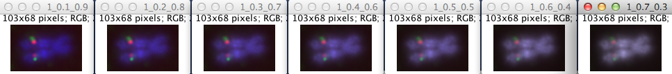A dialog will appear asking if a ROI should be processed or the whole image. If the ROI option is selected there is an opportunity to draw the ROI on the image within the macro.

**Analysis Background Information**

Each lightened RGB image is created by splitting into its 3 colour channels and re-merged as follows:

*x* * blue image + (1-*x*) * red image = red image

*x* * blue image + (1-*x*) * green image = green image

Unaltered blue (DAPI) image

Where x = 0.1, 0.2, 0.3, 0.4, 0.5, 0.6, 0.7